Breezy Conditionals – Programming Assignments ANSWERS
//Breezy Conditionals #1
import java.io.*;
import java.text.*;
import java.awt.*;
import BreezyGUI.*;

public class BreezyAssign1 extends GBFrame
{
Label winningLabel= addLabel("Enter winning amount ($99 or less)",1,1,1,1);
IntegerField winningField= addIntegerField(0,1,2,1,1);

Button issueButton= addButton("Bills to Issue",2,1,2,1);

int num, one, five, ten, twenty, one1, five1, ten1, twenty1 ;

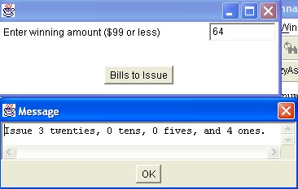
public void buttonClicked (Button buttonObj)
{
num =(winningField.getNumber());
String outputstring;
if(num<=99)
{
twenty=num/20;
twenty1=num%20;
ten=twenty1/10;
ten1=twenty1%10;
five=ten1/5;
five1=ten1%5;
one=five1;

outputstring=("Issue " + twenty + " twenties, " + ten + " tens, " + five + " fives, and " + one +
" ones.");
messageBox(outputstring);
}
else
{
outputstring =("You entered an amount over the maximum of $99.");
messageBox (outputstring);
}
}
public static void main(String[] args)
{
Frame frm = new BreezyAssign1();
frm.setSize (400, 150);
frm.setVisible (true);
}
}

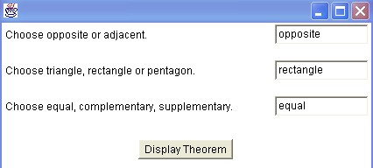
//Breezy Conditionals #2
import java.io.*;
import java.text.*;
import java.awt.*;
import BreezyGUI.*;

public class BreezyAssign2 extends GBFrame
{
Label angleLabel=addLabel("Choose opposite or adjacent.",1,1,1,1);
Label figureLabel=addLabel("Choose triangle, rectangle or pentagon.",2,1,1,1);
Label sizeLabel=addLabel("Choose equal, complementary, supplementary.",3,1,1,1);
TextField angleField=addTextField("",1,2,1,1);
TextField figureField=addTextField("",2,2,1,1);
TextField sizeField=addTextField("",3,2,1,1);

Button displayButton=addButton("Display Theorem",5,1,2,1);
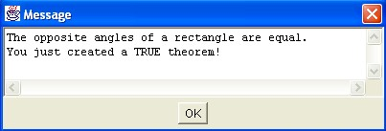
public void buttonClicked (Button buttonObj)
{
String angle, figure, size, outputstring;

angle = angleField.getText();
figure = figureField.getText();
size = sizeField.getText();

if ((angle.equals("opposite")&&figure.equals("rectangle")&& size.equals("equal"))
||(angle.equals("opposite")&&figure.equals("rectangle")&& size.equals("supplementary"))
||(angle.equals("adjacent")&&figure.equals("rectangle")&& size.equals("equal"))
||(angle.equals("adjacent")&&figure.equals("rectangle")&& size.equals("supplementary")))
{
outputstring = ("The " + angle + " angles of a " + figure + " are " + size + "." +
"\nYou just created a TRUE theorem!");
messageBox(outputstring);
}
else
{
outputstring = ("The " + angle + " angles of a " + figure + " are " + size + "." +
"\nSorry, this is not always TRUE!");
messageBox(outputstring);
}
}
public static void main(String[] args)
{
Frame frm=new BreezyAssign2( );
frm.setSize(500,200);
frm.setVisible(true);
}
}
//Breezy Conditionals #3
import java.io.*;
import java.text.*;
import java.awt.*;
import BreezyGUI.*;

public class BreezyAssign3 extends GBFrame
{
Label lengthLabel=addLabel("Length in Centimeters",1,1,1,1);
Label priceLabel=addLabel("Price in dollars $",2,1,1,1);

DoubleField lengthField=addDoubleField(0,1,2,1,1);
DoubleField priceField=addDoubleField(0,2,2,1,1);

Button lengthButton=addButton("Find the length",3,1,1,1);
Button priceButton=addButton("Find the price",3,2,1,1);

public void buttonClicked (Button buttonObj)
{
double price, length;
if(buttonObj==lengthButton)
{
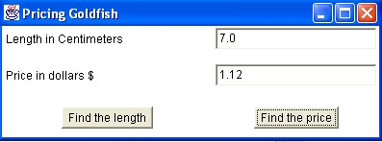
price=priceField.getNumber();
length=price/0.16;
lengthField.setNumber(length);
}
if(buttonObj==priceButton)
{
length=lengthField.getNumber();
price=length*0.16;
priceField.setNumber(price);
priceField.setPrecision(2);
}
}
public static void main(String[] args)
{
Frame frm = new BreezyAssign3();
frm.setSize (400, 150);
frm.setVisible (true);
frm.setTitle("Pricing Goldfish");
}
}

//Not Breezy Conditionals #4 using a series of if statements
import java.io.*;
import java.text.*;
import BreezyGUI.*;

public class NotBreezy4
{
public static void main(String[] args)
{
System.out.println("1. \"The Lion King\" ");
System.out.println("2. \"Top Gun\" ");
System.out.println("3. \"Dirty Dancing\" ");
System.out.println("4. \"The Breakfast Club\" ");
int choice;
choice=Console.readInt("\nWhich movie would you like to review? ");
if(choice==1)
{
System.out.println("\n\"The Lion King\" Starring: James Earl Jones and Matthew Broderick" );
System.out.println("\n Experience the power and majesty that is \"The Lion King\"! With its unforgettable story, Academy Award-winning music, breathtaking animation and beloved characters, you'll be inspired by the tale of Simba, the feisty lion cub who \"just can't wait to be king,\" and his journey to claim his place in the \"Circle of Life\"");
}
else if(choice==2)
{
System.out.println("\n\"Top Gun\" Starring: Tom Cruise and Kelly McGillis");
System.out.println("\n A hip, heart-pounding combination of action, music and incredible aerial photography helped make \"Top Gun\" the blockbuster hit of 1986.");
System.out.println("\n \"Top Gun\" takes a look at the danger and excitement that awaits every pilot at the Navy's prestigious fighter weapons school. Tom Cruise is superb as Maverick Mitchell, a daring young flyer who's out to become the best. And Kelly McGill’s sizzles as the civilian instructor who teaches Maverick a few things you can't learn in a classroom.");
}
else if(choice==3)
{
System.out.println("\n\"Dirty Dancing\" Starring: Patrick Swayze and Jennifer Grey");
System.out.println("\n Heartthrob Patrick Swayze, Jennifer Grey and dancing sensation Cynthia Rhodes star in this electrifying and sensual film. A vivid love story, \"Dirty Dancing\" is set to pounding rhythms and vibrant dance - guaranteed to be the time of your life.");
}
else if(choice==4)
{
System.out.println("\n\"The Breakfast Club\" Starring: Emilio Estevez, Anthony Michael Hall, Judd Nelson, Molly Ringwald, and Ally Sheedy");
System.out.println("\n They were five teenage students with nothing in common, faced with spending a Saturday detention together in their high school library. At seven a.m., they had nothing to say, but by four p.m., they had bared their souls to each other and become good friends.");
System.out.println("\n John Hughes, creator of the critically acclaimed \"Sixteen Candles\", wrote, directed and produced this hilarious and often touching comedy starring Emilio Estevez, Anthony Michael Hall, Judd Nelson, Molly Ringwald, and Ally Sheedy. To the outside world they were simply the Jock, the Brain, the Criminal, the Princess, and the Kook, but to each other, the would always be The Breakfast Club.");
}
else
{
System.out.println("\nI'm sorry, but that is an invalid choice.");
}
}
}

